For PFW invoicing you create an invoice in Order Entry the same as any other invoice.

Once an invoice is created, you need to go to Payables and Enter the invoice to pay like entering an invoice from any Vendor. The Vendor # when you are entering a PFW invoice is **PFWPRO.**

Once an invoice is created and entered in Accounts Payable, Checks , new batch select the bank account INTDPT for Interdepartment Clearing

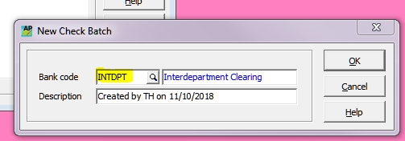

you pay the invoice with a “cheque” that is printed on a piece of paper not a cheque (a “dummy cheque”). The cheque # should be **different** than what is in sequence of actual cheques.

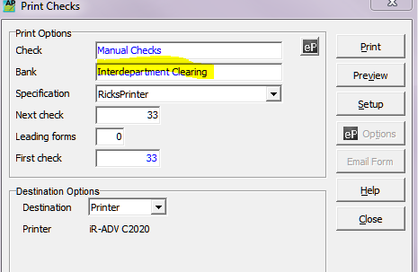

Make sure the Bank says Interdepartment Clearing when you are printing

Receive the payment in Accounts Receivables with the payment method being “inter-company clearing”.